1-Rhythm

🔹 What Is Rhythm?
# Source: AI Source: Provided by: [Data Path: Persons Table -> ID Column: 1, Name_En Column: Motasem Essam] -> From: [Chatgpt (GPT-4-turbo)] on [7/30/2025]
Rhythm in language—especially in poetry and speech—is the pattern of stressed and unstressed syllables, beats, or timing that gives the text a sense of movement, flow, or musicality.
It’s the beat or pulse you feel when a poem is read aloud.

✅ Definition (Simple)
# Source: AI Source: Provided by: [Data Path: Persons Table -> ID Column: 1, Name_En Column: Motasem Essam] -> From: [Chatgpt (GPT-4-turbo)] on [7/30/2025]
Rhythm is the measured flow of words based on the pattern of syllables—especially stressed (´) and unstressed (˘) ones.

🧠 Key Characteristics of Rhythm
# Source: AI Source: Provided by: [Data Path: Persons Table -> ID Column: 1, Name_En Column: Motasem Essam] -> From: [Chatgpt (GPT-4-turbo)] on [7/30/2025]
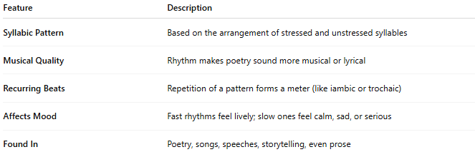
Feature | Description
Syllabic Pattern | Based on the arrangement of stressed and unstressed syllables
Musical Quality | Rhythm makes poetry sound more musical or lyrical
Recurring Beats | Repetition of a pattern forms a meter (like iambic or trochaic)
Affects Mood | Fast rhythms feel lively; slow ones feel calm, sad, or serious
Found In | Poetry, songs, speeches, storytelling, even prose

🧪 Examples of Rhythm in Poetry

🔸 Iambic Rhythm (˘ ´):
# Source: AI Source: Provided by: [Data Path: Persons Table -> ID Column: 1, Name_En Column: Motasem Essam] -> From: [Chatgpt (GPT-4-turbo)] on [7/30/2025]
da-DUM da-DUM da-DUM da-DUM
"I walked the road and saw the sky."
➡ Alternates unstressed + stressed

🔸 Trochaic Rhythm (´ ˘):
# Source: AI Source: Provided by: [Data Path: Persons Table -> ID Column: 1, Name_En Column: Motasem Essam] -> From: [Chatgpt (GPT-4-turbo)] on [7/30/2025]
DUM-da DUM-da DUM-da DUM
"Running through the shadows quiet"
➡ Alternates stressed + unstressed

🧩 Rhythm vs Meter
# Source: AI Source: Provided by: [Data Path: Persons Table -> ID Column: 1, Name_En Column: Motasem Essam] -> From: [Chatgpt (GPT-4-turbo)] on [7/30/2025]
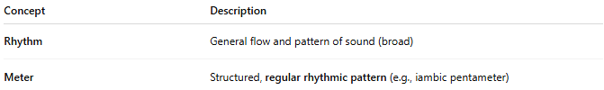
Concept | Description
Rhythm | General flow and pattern of sound (broad)
Meter | Structured, regular rhythmic pattern (e.g., iambic pentameter)

🎵 Rhythm in Other Contexts
# Source: AI Source: Provided by: [Data Path: Persons Table -> ID Column: 1, Name_En Column: Motasem Essam] -> From: [Chatgpt (GPT-4-turbo)] on [7/30/2025]
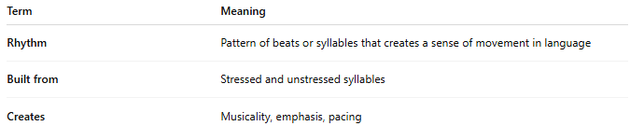

Context | How Rhythm Appears
Poetry | Syllable stress and line patterns
Music | Beats, tempo, timing
Speech | Natural rise/fall in phrasing
Prose | Sentence length, pauses, repetition

✅ Summary
# Source: AI Source: Provided by: [Data Path: Persons Table -> ID Column: 1, Name_En Column: Motasem Essam] -> From: [Chatgpt (GPT-4-turbo)] on [7/30/2025]


Term | Meaning
Rhythm | Pattern of beats or syllables that creates a sense of movement in language
Built from | Stressed and unstressed syllables
Creates | Musicality, emphasis, pacing

2-Rhyme

🎵 What Is Rhyme?
# Source: AI Source: Provided by: [Data Path: Persons Table -> ID Column: 1, Name_En Column: Motasem Essam] -> From: [Chatgpt (GPT-4-turbo)] on [7/30/2025]
Rhyme is the repetition of similar or identical sounds at the end of two or more words, most often used in poetry, songs, and lyrical writing to create rhythm, musicality, or emphasis.

🔹 Definition:
# Source: AI Source: Provided by: [Data Path: Persons Table -> ID Column: 1, Name_En Column: Motasem Essam] -> From: [Chatgpt (GPT-4-turbo)] on [7/30/2025]
A rhyme is a repetition of ending sounds in words, typically from the last stressed syllable onward.

🔸 Basic Example:
# Source: AI Source: Provided by: [Data Path: Persons Table -> ID Column: 1, Name_En Column: Motasem Essam] -> From: [Chatgpt (GPT-4-turbo)] on [7/30/2025]
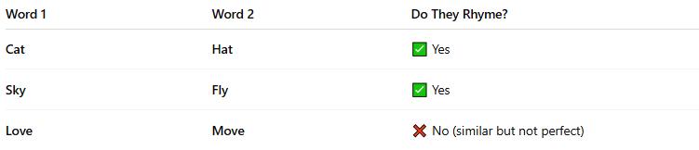
Word 1 | Word 2 | Do They Rhyme?
Cat | Hat | ✅ Yes
Sky | Fly | ✅ Yes
Love | Move | ❌ No (similar but not perfect)

🧱 Structure of Rhyme:
# Source: AI Source: Provided by: [Data Path: Persons Table -> ID Column: 1, Name_En Column: Motasem Essam] -> From: [Chatgpt (GPT-4-turbo)] on [7/30/2025]
A rhyme usually consists of:
- Rhyming vowel sounds (e.g., ee, oo, ay)
- Possibly matching consonants after the vowels
🗣 Example: “light” and “fight” rhyme because they both end in -ight.

📚 Common Uses of Rhyme:
# Source: AI Source: Provided by: [Data Path: Persons Table -> ID Column: 1, Name_En Column: Motasem Essam] -> From: [Chatgpt (GPT-4-turbo)] on [7/30/2025]
- Poetry (e.g., sonnets, nursery rhymes)
- Song lyrics
- Advertisements and slogans
- Language learning (helps memory)

🔍 Types of Rhymes (in brief):
# Source: AI Source: Provided by: [Data Path: Persons Table -> ID Column: 1, Name_En Column: Motasem Essam] -> From: [Chatgpt (GPT-4-turbo)] on [7/30/2025]
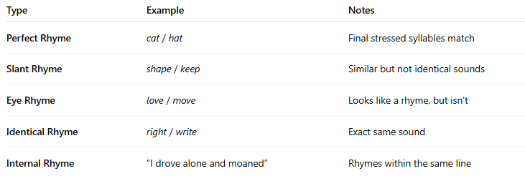
Type | Example | Notes
Perfect Rhyme | cat / hat | Final stressed syllables match
Slant Rhyme | shape / keep | Similar but not identical sounds
Eye Rhyme | love / move | Looks like a rhyme, but isn’t
Identical Rhyme | right / write | Exact same sound
Internal Rhyme | “I drove alone and moaned” | Rhymes within the same line

Rhymes Covered

🎼 What Is "Rhymes Covered"?
# Source: AI Source: Provided by: [Data Path: Persons Table -> ID Column: 1, Name_En Column: Motasem Essam] -> From: [Chatgpt (GPT-4-turbo)] on [7/30/2025]
The phrase “Rhymes Covered” isn't a standard linguistic term, but in context—especially in educational or reference materials—it usually refers to:
The range or types of rhymes that are included, addressed, or explained in a dictionary, study, or lesson on rhyme.

🟢 In Practice, "Rhymes Covered" May Mean:
# Source: AI Source: Provided by: [Data Path: Persons Table -> ID Column: 1, Name_En Column: Motasem Essam] -> From: [Chatgpt (GPT-4-turbo)] on [7/30/2025]
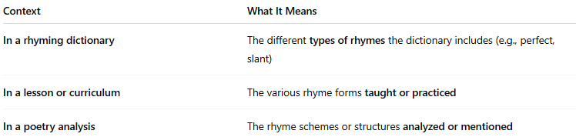
Context | What It Means
In a rhyming dictionary | The different types of rhymes the dictionary includes (e.g., perfect, slant)
In a lesson or curriculum | The various rhyme forms taught or practiced
In a poetry analysis | The rhyme schemes or structures analyzed or mentioned

📚 Examples of Rhymes Typically Covered:
# Source: AI Source: Provided by: [Data Path: Persons Table -> ID Column: 1, Name_En Column: Motasem Essam] -> From: [Chatgpt (GPT-4-turbo)] on [7/30/2025]
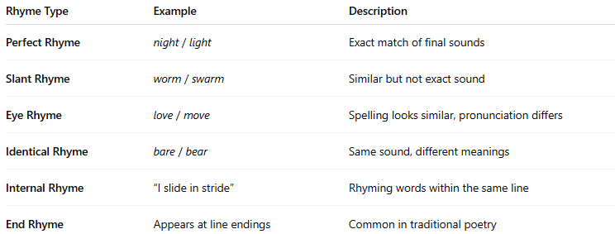
Rhyme Type | Example | Description
Perfect Rhyme | night / light | Exact match of final sounds
Slant Rhyme | worm / swarm | Similar but not exact sound
Eye Rhyme | love / move | Spelling looks similar, pronunciation differs
Identical Rhyme | bare / bear | Same sound, different meanings
Internal Rhyme | “I slide in stride” | Rhyming words within the same line
End Rhyme | Appears at line endings | Common in traditional poetry

🧠 Summary:
# Source: AI Source: Provided by: [Data Path: Persons Table -> ID Column: 1, Name_En Column: Motasem Essam] -> From: [Chatgpt (GPT-4-turbo)] on [7/30/2025]
"Rhymes Covered" = The rhyme types or rhyme-related content included in a resource (like a dictionary, book, course, or poem).

Rhythm and Rhyme

🔗 Relation Between Rhythm and Rhyme
# Source: AI Source: Provided by: [Data Path: Persons Table -> ID Column: 1, Name_En Column: Motasem Essam] -> From: [Chatgpt (GPT-4-turbo)] on [7/30/2025]
Rhythm and rhyme are both essential elements of poetry and song—but they serve different functions and work together to create musicality, structure, and aesthetic pleasure in language.

🧠 Definitions First
# Source: AI Source: Provided by: [Data Path: Persons Table -> ID Column: 1, Name_En Column: Motasem Essam] -> From: [Chatgpt (GPT-4-turbo)] on [7/30/2025]
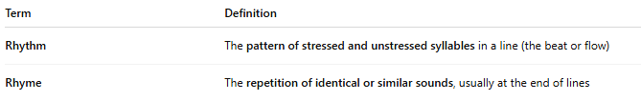
Term | Definition
Rhythm | The pattern of stressed and unstressed syllables in a line (the beat or flow)
Rhyme | The repetition of identical or similar sounds, usually at the end of lines

🔄 Comparison Table
# Source: AI Source: Provided by: [Data Path: Persons Table -> ID Column: 1, Name_En Column: Motasem Essam] -> From: [Chatgpt (GPT-4-turbo)] on [7/30/2025]
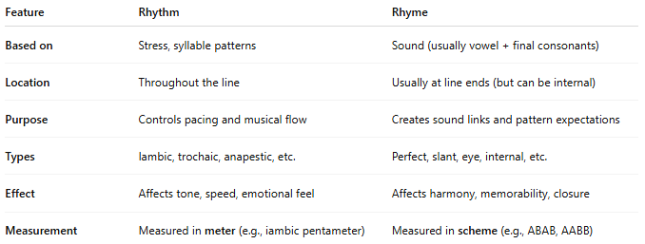
Feature | Rhythm | Rhyme
Based on | Stress, syllable patterns | Sound (usually vowel + final consonants)
Location | Throughout the line | Usually at line ends (but can be internal)
Purpose | Controls pacing and musical flow | Creates sound links and pattern expectations
Types | Iambic, trochaic, anapestic, etc. | Perfect, slant, eye, internal, etc.
Effect | Affects tone, speed, emotional feel | Affects harmony, memorability, closure
Measurement | Measured in meter (e.g., iambic pentameter) | Measured in scheme (e.g., ABAB, AABB)

🎯 How Rhythm and Rhyme Work Together
# Source: AI Source: Provided by: [Data Path: Persons Table -> ID Column: 1, Name_En Column: Motasem Essam] -> From: [Chatgpt (GPT-4-turbo)] on [7/30/2025]
They often appear together in verse, complementing each other:
- Rhythm gives structure and flow
- Rhyme gives sound unity and pattern
✅ Example (iambic rhythm + end rhyme):
The sun went down, and stars were bright
We wandered far into the night
- Rhythm: iambic tetrameter (˘ ´ ˘ ´ ˘ ´ ˘ ´)
- Rhyme: down / bright and far / night → AABB

🔄 Interplay Example
# Source: AI Source: Provided by: [Data Path: Persons Table -> ID Column: 1, Name_En Column: Motasem Essam] -> From: [Chatgpt (GPT-4-turbo)] on [7/30/2025]
In music or poetry, rhyme might emphasize rhythm, and rhythm might highlight rhyme:
She danced along the broken floor
And tapped in time just like before
- The rhythm makes it predictable and pleasant
- The rhyme makes it memorable and musical

✅ Summary: The Relationship
# Source: AI Source: Provided by: [Data Path: Persons Table -> ID Column: 1, Name_En Column: Motasem Essam] -> From: [Chatgpt (GPT-4-turbo)] on [7/30/2025]
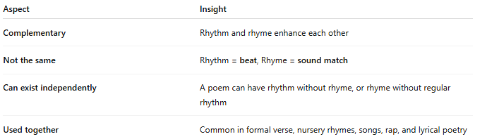
Aspect | Insight
Complementary | Rhythm and rhyme enhance each other
Not the same | Rhythm = beat, Rhyme = sound match
Can exist independently | A poem can have rhythm without rhyme, or rhyme without regular rhythm
Used together | Common in formal verse, nursery rhymes, songs, rap, and lyrical poetry

3-Meter

🔹 What Is Meter (Poetic)
# Source: AI Source: Provided by: [Data Path: Persons Table -> ID Column: 1, Name_En Column: Motasem Essam] -> From: [Chatgpt (GPT-4-turbo)] on [7/30/2025]
⚠️ Note: "Meter" is not a type of homograph, but the word "meter" is a homograph — a word that shares spelling with another but differs in meaning and sometimes pronunciation.

✅ Homograph: "Meter"
# Source: AI Source: Provided by: [Data Path: Persons Table -> ID Column: 1, Name_En Column: Motasem Essam] -> From: [Chatgpt (GPT-4-turbo)] on [7/30/2025]
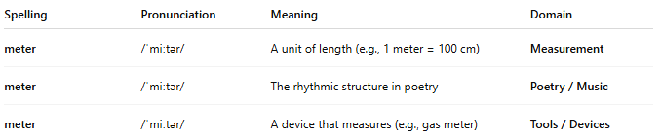
Spelling | Pronunciation | Meaning | Domain
meter | /ˈmiːtər/ | A unit of length (e.g., 1 meter = 100 cm) | Measurement
meter | /ˈmiːtər/ | The rhythmic structure in poetry | Poetry / Music
meter | /ˈmiːtər/ | A device that measures (e.g., gas meter) | Tools / Devices
→ These are true homographs: same spelling, same pronunciation, different meanings.

🧠 What Is Meter (in Poetry)?
# Source: AI Source: Provided by: [Data Path: Persons Table -> ID Column: 1, Name_En Column: Motasem Essam] -> From: [Chatgpt (GPT-4-turbo)] on [7/30/2025]
Meter is a structured pattern of rhythm in a line of poetry, defined by:
- Type of foot (unit of rhythm)
- Number of feet per line

📏 Types of Poetic Meter (Not Homographs)
# Source: AI Source: Provided by: [Data Path: Persons Table -> ID Column: 1, Name_En Column: Motasem Essam] -> From: [Chatgpt (GPT-4-turbo)] on [7/30/2025]
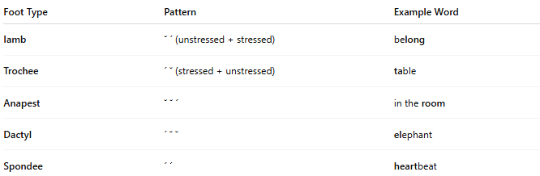
Foot Type | Pattern | Example Word
Iamb | ˘ ´ (unstressed + stressed) | belong
Trochee | ´ ˘ (stressed + unstressed) | table
Anapest | ˘ ˘ ´ | in the room
Dactyl | ´ ˘ ˘ | elephant
Spondee | ´ ´ | heartbeat
➕ Combine with number of feet per line (e.g., 5 feet = pentameter):
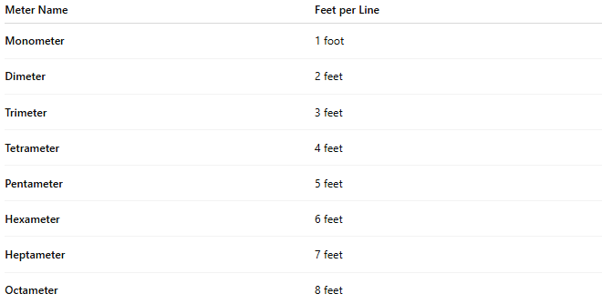
Meter Name | Feet per Line
Monometer | 1 foot
Dimeter | 2 feet
Trimeter | 3 feet
Tetrameter | 4 feet
Pentameter | 5 feet
Hexameter | 6 feet
Heptameter | 7 feet
Octameter | 8 feet

🔗 Connection to Homographs
# Source: AI Source: Provided by: [Data Path: Persons Table -> ID Column: 1, Name_En Column: Motasem Essam] -> From: [Chatgpt (GPT-4-turbo)] on [7/30/2025]
So, when we say:
- “This poem is written in iambic meter,” we’re using the poetic sense.
- “The pipe was measured with a meter,” we’re using the scientific/instrumental sense.
💡 All are homographs—same spelling, different meanings.

✅ Summary
# Source: AI Source: Provided by: [Data Path: Persons Table -> ID Column: 1, Name_En Column: Motasem Essam] -> From: [Chatgpt (GPT-4-turbo)] on [7/30/2025]
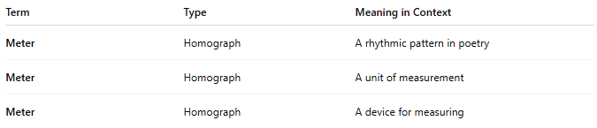
Term | Type | Meaning in Context
Meter | Homograph | A rhythmic pattern in poetry
Meter | Homograph | A unit of measurement
Meter | Homograph | A device for measuring

4-Metrical Foot

🟦 What Is a Metrical Foot?
# Source: AI Source: Provided by: [Data Path: Persons Table -> ID Column: 1, Name_En Column: Motasem Essam] -> From: [Chatgpt (GPT-4-turbo)] on [7/30/2025]
A metrical foot is the basic unit of rhythm in poetry. It consists of a specific combination of stressed (´) and unstressed (˘) syllables.
📚 Think of it like a musical beat—just using syllables instead of notes.

🧱 Structure of a Metrical Foot
# Source: AI Source: Provided by: [Data Path: Persons Table -> ID Column: 1, Name_En Column: Motasem Essam] -> From: [Chatgpt (GPT-4-turbo)] on [7/30/2025]
Each metrical foot has a fixed number of syllables, with a particular pattern of stress:
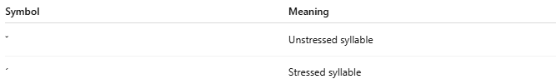
Symbol | Meaning
˘ | Unstressed syllable
´ | Stressed syllable

🔢 Common Types of Metrical Feet
# Source: AI Source: Provided by: [Data Path: Persons Table -> ID Column: 1, Name_En Column: Motasem Essam] -> From: [Chatgpt (GPT-4-turbo)] on [7/30/2025]
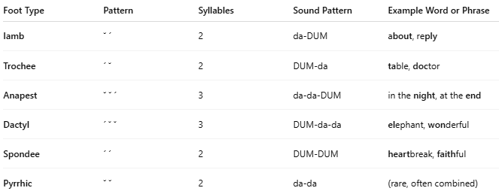
Foot Type | Pattern | Syllables | Sound Pattern | Example Word or Phrase
Iamb | ˘ ´ | 2 | da-DUM | about, reply
Trochee | ´ ˘ | 2 | DUM-da | table, doctor
Anapest | ˘ ˘ ´ | 3 | da-da-DUM | in the night, at the end
Dactyl | ´ ˘ ˘ | 3 | DUM-da-da | elephant, wonderful
Spondee | ´ ´ | 2 | DUM-DUM | heartbreak, faithful
Pyrrhic | ˘ ˘ | 2 | da-da | (rare, often combined)

🎵 Metrical Foot vs Meter
# Source: AI Source: Provided by: [Data Path: Persons Table -> ID Column: 1, Name_En Column: Motasem Essam] -> From: [Chatgpt (GPT-4-turbo)] on [7/30/2025]
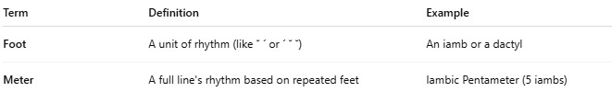
Term | Definition | Example
Foot | A unit of rhythm (like ˘ ´ or ´ ˘ ˘) | An iamb or a dactyl
Meter | A full line's rhythm based on repeated feet | Iambic Pentameter (5 iambs)

📝 Example Line (Iambic Meter):
# Source: AI Source: Provided by: [Data Path: Persons Table -> ID Column: 1, Name_En Column: Motasem Essam] -> From: [Chatgpt (GPT-4-turbo)] on [7/30/2025]
“To be, or not to be, that is the question.”
→ 5 iambs → ˘ ´ ˘ ´ ˘ ´ ˘ ´ ˘ ´
→ This line is in iambic pentameter

🧠 Summary
# Source: AI Source: Provided by: [Data Path: Persons Table -> ID Column: 1, Name_En Column: Motasem Essam] -> From: [Chatgpt (GPT-4-turbo)] on [7/30/2025]
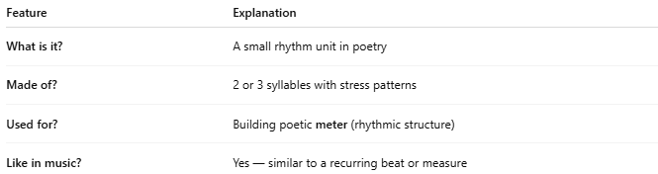
Feature | Explanation
What is it? | A small rhythm unit in poetry
Made of? | 2 or 3 syllables with stress patterns
Used for? | Building poetic meter (rhythmic structure)
Like in music? | Yes — similar to a recurring beat or measure

5-Metrical Pattern

🟨 What Is a Metrical Pattern?
# Source: AI Source: Provided by: [Data Path: Persons Table -> ID Column: 1, Name_En Column: Motasem Essam] -> From: [Chatgpt (GPT-4-turbo)] on [7/30/2025]
A metrical pattern is the regular rhythm of stressed and unstressed syllables in a line of poetry. It forms the beat or structure of a poem—like a musical rhythm in words.
Think of it as the “sound formula” of a poem.

🎵 Basic Building Block: The Metrical Foot
# Source: AI Source: Provided by: [Data Path: Persons Table -> ID Column: 1, Name_En Column: Motasem Essam] -> From: [Chatgpt (GPT-4-turbo)] on [7/30/2025]
A metrical foot is a unit of rhythm made up of a fixed number and type of syllables—some stressed (´) and some unstressed (˘).
Common types of metrical feet:
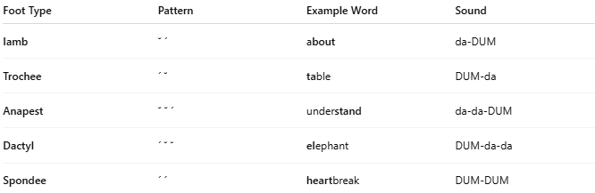
Foot Type | Pattern | Example Word | Sound
Iamb | ˘ ´ | about | da-DUM
Trochee | ´ ˘ | table | DUM-da
Anapest | ˘ ˘ ´ | understand | da-da-DUM
Dactyl | ´ ˘ ˘ | elephant | DUM-da-da
Spondee | ´ ´ | heartbreak | DUM-DUM

🧱 Metrical Pattern = Foot + Repetition
# Source: AI Source: Provided by: [Data Path: Persons Table -> ID Column: 1, Name_En Column: Motasem Essam] -> From: [Chatgpt (GPT-4-turbo)] on [7/30/2025]
When a type of foot is repeated a certain number of times per line, you get a metrical pattern (or meter).
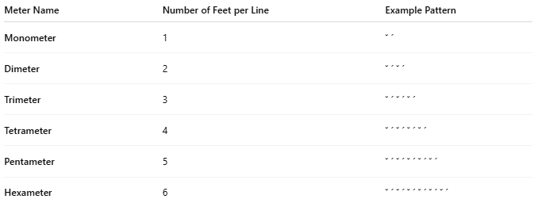
Meter Name | Number of Feet per Line | Example Pattern
Monometer | 1 | ˘ ´
Dimeter | 2 | ˘ ´ ˘ ´
Trimeter | 3 | ˘ ´ ˘ ´ ˘ ´
Tetrameter | 4 | ˘ ´ ˘ ´ ˘ ´ ˘ ´
Pentameter | 5 | ˘ ´ ˘ ´ ˘ ´ ˘ ´ ˘ ´
Hexameter | 6 | ˘ ´ ˘ ´ ˘ ´ ˘ ´ ˘ ´ ˘ ´

📘 Example of Metrical Pattern (Iambic Pentameter)
# Source: AI Source: Provided by: [Data Path: Persons Table -> ID Column: 1, Name_En Column: Motasem Essam] -> From: [Chatgpt (GPT-4-turbo)] on [7/30/2025]
“Shall I compare thee to a summer’s day?”
→ 5 iambs: ˘ ´ ˘ ´ ˘ ´ ˘ ´ ˘ ´
→ Iambic Pentameter

🧠 Summary:
# Source: AI Source: Provided by: [Data Path: Persons Table -> ID Column: 1, Name_En Column: Motasem Essam] -> From: [Chatgpt (GPT-4-turbo)] on [7/30/2025]
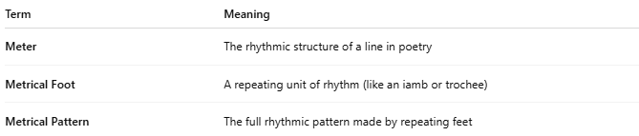
Term | Meaning
Meter | The rhythmic structure of a line in poetry
Metrical Foot | A repeating unit of rhythm (like an iamb or trochee)
Metrical Pattern | The full rhythmic pattern made by repeating feet

